How I Study the Bible—an Example
The examples that follow are 1 Samuel 17, some verses from Matthew 13, the first three chapters of the Gospel of John, and the first chapter of 1 Corinthians.

- I incorporate different translations into the text if I think one is better than another. Mostly I use ESV and NIV but NASB gets inserted at times.
- I have altered the punctuation slightly in places to fit my style. For example, since I have put Jesus’ words in red font I don’t feel the need to have His words begin and end in quotation marks (it’s just my preference). If a passage has a chiastic structure then I reflect that in the passage (see Matt. 13).
- Sometimes I will include an outline, as I did for 1 Corinthians (I used the outline of Gordon Fee’s commentary on 1 Corinthians).
- Sometimes I’ve altered the text based on what I read in commentaries (remember, this is my Bible that I use for me—I don’t teach directly from it).
- I don’t bother to use full footnoting since, again, this is only for my personal benefit. For example, “NAC” stands for New American Commentary (most of the volumes are excellent, by the way) and “Carson” is all I use to refer to his commentaries on Matthew or John (which are excellent). I highlight footnote numbers in various colors depending on their importance to me.
- I use heading level 1 for the chapter titles—that way I can use the Microsoft Word’s navigation pane to move around in the document (if you don’t know what that is, Google it).
- Although I didn’t give any examples of it below, often I will insert sermon outlines in my Bible.

Reading the Bible this way is a joy to me and I hope that this will inspire some readers to do likewise in their Bible study.

I Samuel

1 Samuel 17
David and Goliath
¹ Now the Philistines gathered their forces for war and assembled at Socoh in Judah. They pitched camp at Ephes Dammim, between Socoh and Azekah.

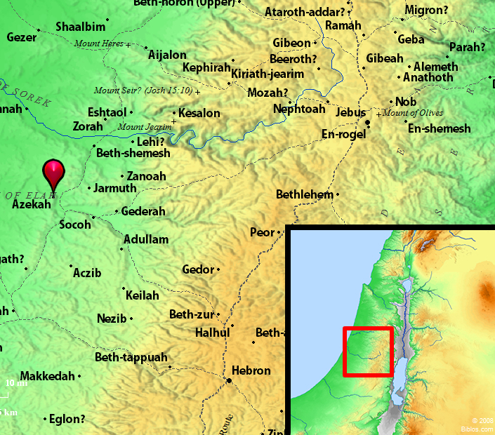
² Saul and the Israelites assembled and camped in the Valley of Elah and drew up their battle line to meet the Philistines.

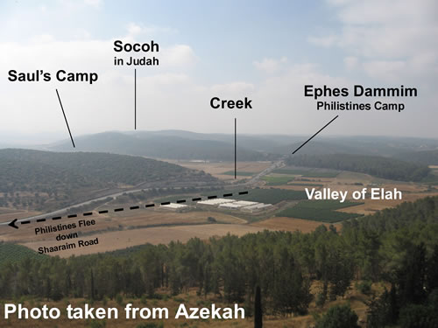

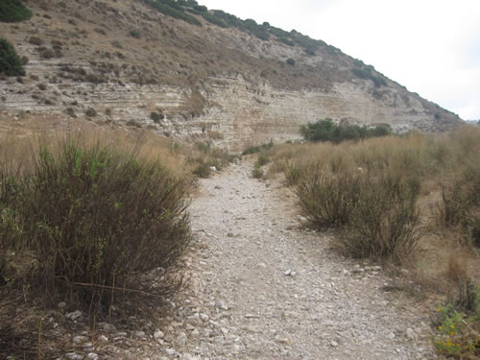
Dry Creek—Valley of Elah

³ The Philistines occupied one hill and the Israelites another, with the valley between them.

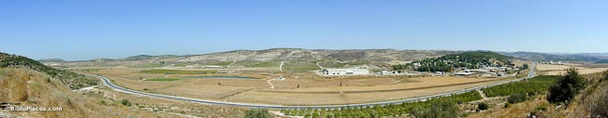The Philistine’s view
⁴ A champion named Goliath, who was from Gath, came out of the Philistine camp. He was over nine feet tall. ⁵ He had a bronze helmet on his head and wore a coat of scale armor of bronze weighing 126 pounds; ⁶ on his legs he wore bronze greaves, and a bronze javelin was slung on his back. ⁷ His spear shaft was like a weaver’s rod, and its iron point weighed fifteen pounds. His shield bearer went ahead of him.

⁸ Goliath stood and shouted to the ranks of Israel, “Why do you come out and line up for battle? Am I not a Philistine, and are you not the servants of Saul? Choose a man and have him come down to me. ⁹ If he is able to fight and kill me, we will become your subjects; but if I overcome him and kill him, you will become our subjects and serve us.” ¹⁰ Then the Philistine said, “This day I defy the ranks of Israel! Give me a man and let us fight each other.” ¹¹ On hearing the Philistine’s words, Saul and all the Israelites were dismayed and terrified.

¹² Now David was the son of an Ephrathite named Jesse, who was from Bethlehem in Judah. Jesse had eight sons, and in Saul’s time he was old and well advanced in years. ¹³ Jesse’s three oldest sons had followed Saul to the war: The firstborn was Eliab; the second, Abinadab; and the third, Shammah. ¹⁴ David was the youngest. The three oldest followed Saul, ¹⁵ but David went back and forth from Saul to tend his father’s sheep at Bethlehem.

¹⁶ For forty days the Philistine came forward every morning and evening and took his stand.

¹⁷ Now Jesse said to his son David, “Take this ephah of roasted grain and these ten loaves of bread for your brothers and hurry to their camp. ¹⁸ Take along these ten cheeses to the commander of their unit. See how your brothers are and bring back some assurance from them. ¹⁹ They are with Saul and all the men of Israel in the Valley of Elah, fighting against the Philistines.”

²⁰ Early in the morning David left the flock with a shepherd, loaded up and set out, as Jesse had directed. He reached the camp as the army was going out to its battle positions, shouting the war cry. ²¹ Israel and the Philistines were drawing up their lines facing each other. ²² David left his things with the keeper of supplies, ran to the battle lines and greeted his brothers. ²³ As he was talking with them, Goliath, the Philistine champion from Gath, stepped out from his lines and shouted his usual defiance, and David heard it. ²⁴ When the Israelites saw the man, they all ran from him in great fear.

²⁵ Now the Israelites had been saying, “Do you see how this man keeps coming out? He comes out to defy Israel. The king will give great wealth to the man who kills him. He will also give him his daughter in marriage and will exempt his father’s family from taxes in Israel.”

²⁶ David asked the men standing near him, “What will be done for the man who kills this Philistine and removes this disgrace from Israel? Who is this uncircumcised Philistine that he should defy the armies of the living God?”

²⁷ They repeated to him what they had been saying and told him, “This is what will be done for the man who kills him.”

²⁸ When Eliab, David’s oldest brother, heard him speaking with the men, he burned with anger at him and asked, “Why have you come down here? And with whom did you leave those few sheep in the desert? I know how conceited you are and how wicked your heart is; you came down only to watch the battle.”

²⁹ “Now what have I done?” said David. “Can’t I even speak?” ³⁰ He then turned away to someone else and brought up the same matter, and the men answered him as before. ³¹ What David said was overheard and reported to Saul, and Saul sent for him.

³² David said to Saul, “Let no one lose heart on account of this Philistine; your servant will go and fight him.”

³³ Saul replied, “You are not able to go out against this Philistine and fight him; you are only a boy, and he has been a fighting man from his youth.”

³⁴ But David said to Saul, “Your servant has been keeping his father’s sheep. When a lion or a bear came and carried off a sheep from the flock, ³⁵ I went after it, struck it and rescued the sheep from its mouth. When it turned on me, I seized it by its hair, struck it and killed it. ³⁶ Your servant has killed both the lion and the bear; this uncircumcised Philistine will be like one of them, because he has defied the armies of the living God. ³⁷ The LORD who delivered me from the paw of the lion and the paw of the bear will deliver me from the hand of this Philistine.”

Saul said to David, “Go, and the LORD be with you.”

³⁸ Then Saul dressed David in his own tunic. He put a coat of armor on him and a bronze helmet on his head. ³⁹ David fastened on his sword over the tunic and tried walking around, because he was not used to them.

“I cannot go in these,” he said to Saul, “because I am not used to them.” So he took them off. ⁴⁰ Then he took his staff in his hand, chose five smooth stones from the stream, put them in the pouch of his shepherd’s bag and, with his sling in his hand, approached the Philistine.

⁴¹ Meanwhile, the Philistine, with his shield bearer in front of him, kept coming closer to David. ⁴² He looked David over and saw that he was only a boy, ruddy and handsome, and he despised him. ⁴³ He said to David, “Am I a dog, that you come at me with sticks?” And the Philistine cursed David by his gods. ⁴⁴ “Come here,” he said, “and I’ll give your flesh to the birds of the air and the beasts of the field!”

⁴⁵ David said to the Philistine, “You come against me with sword and spear and javelin, but I come against you in the name of the LORD Almighty, the God of the armies of Israel, whom you have defied. ⁴⁶ This day the LORD will hand you over to me, and I’ll strike you down and cut off your head. Today I will give the carcasses of the Philistine army to the birds of the air and the beasts of the earth, and the whole world will know that there is a God in Israel. ⁴⁷ All those gathered here will know that it is not by sword or spear that the LORD saves; for the battle is the LORD’s, and he will give all of you into our hands.”

⁴⁸ As the Philistine moved closer to attack him, David ran quickly toward the battle line to meet him. ⁴⁹ Reaching into his bag and taking out a stone, he slung it and struck the Philistine on the forehead. The stone sank into his forehead, and he fell facedown on the ground.

⁵⁰ So David triumphed over the Philistine with a sling and a stone; without a sword in his hand he struck down the Philistine and killed him.

⁵¹ David ran and stood over him. He took hold of the Philistine’s sword and drew it from the scabbard. After he killed him, he cut off his head with the sword.

When the Philistines saw that their hero was dead, they turned and ran. ⁵² Then the men of Israel and Judah surged forward with a shout and pursued the Philistines to the entrance of Gath and to the gates of Ekron. Their dead were strewn along the Shaaraim road to Gath and Ekron. ⁵³ When the Israelites returned from chasing the Philistines, they plundered their camp. ⁵⁴ David took the Philistine’s head and brought it to Jerusalem, and he put the Philistine’s weapons in his own tent.

⁵⁵ As Saul watched David going out to meet the Philistine, he said to Abner, commander of the army, “Abner, whose son is that young man?”

Abner replied, “As surely as you live, O king, I don’t know.”

⁵⁶ The king said, “Find out whose son this young man is.”

⁵⁷ As soon as David returned from killing the Philistine, Abner took him and brought him before Saul, with David still holding the Philistine’s head.

⁵⁸ “Whose son are you, young man?” Saul asked him.

David said, “I am the son of your servant Jesse of Bethlehem.”

Matthew

Matthew 13

The Sower
13:1 That same day Jesus went out of the house and sat by the lake. 2 Such large crowds gathered around him that he got into a boat and sat in it, while all the people stood on the shore. 3 Then he told them many things in parables, saying: A farmer went out to sow his seed. 4 As he was scattering the seed, some fell along the path, and the birds came and ate it up. 5 Some fell on rocky places, where it did not have much soil. It sprang up quickly, because the soil was shallow. 6 But when the sun came up, the plants were scorched, and they withered because they had no root. 7 Other seed fell among thorns, which grew up and choked the plants. 8 Still other seed fell on good soil, where it produced a crop—a hundred, sixty or thirty times what was sown. 9 He who has ears, let him hear.

Why Jesus speaks in parables
10 The disciples came to him and asked, “Why do you speak to the people in parables?”

11 He replied, The knowledge of the secrets of the kingdom of heaven has been given to you, but not to them. 12 Whoever has will be given more, and he will have an abundance. Whoever does not have, even what he has will be taken from him. 13 This is why I speak to them in parables:

1 “Though seeing, they do not see; though hearing, they do not hear or understand.”
2 14 In them is fulfilled the prophecy of Isaiah:
3 You will be ever hearing but never understanding;
4 you will be ever seeing but never perceiving.
5 15 For this people’s heart has become calloused;
6 they hardly hear with their ears,
7 and they have closed their eyes.
7’ Otherwise they might see with their eyes,
6’ hear with their ears,
5’understand with their hearts and turn, and I would heal them.
4’ 16 But blessed are your eyes because they see,
3’ and your ears because they hear.
2’ 17 For I tell you the truth, many prophets and righteous men
1’ longed to see what you see but did not see it, and to hear what you hear but did not hear it.

Sower explained
18 Listen then to what the parable of the sower means: 19 When anyone hears the message about the kingdom and does not understand it, the evil one comes and snatches away what was sown in his heart. This is the seed sown along the path. 20 The one who received the seed that fell on rocky places is the man who hears the word and at once receives it with joy. 21 But since he has no root, he lasts only a short time. When trouble or persecution comes because of the word, he quickly falls away. 22 The one who received the seed that fell among the thorns is the man who hears the word, but the worries of this life and the deceitfulness of wealth choke it, making it unfruitful. 23 But the one who received the seed that fell on good soil is the man who hears the word and understands it. He produces a crop, yielding a hundred, sixty or thirty times what was sown.

Weeds and wheat
24 Jesus told them another parable: The kingdom of heaven is like a man who sowed good seed in his field. 25 But while everyone was sleeping, his enemy came and sowed weeds among the wheat, and went away. 26 When the wheat sprouted and formed heads, then the weeds also appeared.

27 The owner’s servants came to him and said, “Sir, didn’t you sow good seed in your field? Where then did the weeds come from?”

28 “An enemy did this,” he replied.

The servants asked him, “Do you want us to go and pull them up?”

29 “No,” he answered, “because while you are pulling the weeds, you may root up the wheat with them. 30 Let both grow together until the harvest. At that time I will tell the harvesters: First collect the weeds and tie them in bundles to be burned; then gather the wheat and bring it into my barn.”

Mustard seed
31 He told them another parable: The kingdom of heaven is like a mustard seed, which a man took and planted in his field. 32 Though it is the smallest of all your seeds, yet when it grows, it is the largest of garden plants and becomes a tree, so that the birds of the air come and perch in its branches.

John

John 1
The Word Became Flesh
¹ In the beginning was the Word, and the Word was with God, and the Word was God. ² He was with God in the beginning.

³ Through him all things were made; without him nothing was made that has been made. ⁴ In him was life, and that life was the light of men. ⁵ The light shines in the darkness, but the darkness has not understood it.

⁶ There came a man who was sent from God; his name was John. ⁷ He came as a witness to testify concerning that light, so that through him all men might believe. ⁸ He himself was not the light; he came only as a witness to the light. ⁹ The true light that gives light to every man was coming into the world.

¹⁰ He was in the world, and though the world was made through him, the world did not recognize him. ¹¹ He came to that which was his own, but his own did not receive him. ¹² Yet to all who received him, to those who believed in his name, he gave the right to become children of God—¹³ children born not of blood, nor of the desire of the flesh or will of man, but born of God.

¹⁴ The Word became flesh and made his dwelling among us. We have seen his glory, the glory of the One and Only, who came from the Father, full of grace and truth.

¹⁵ John testifies concerning him. He cries out, saying, “This was he of whom I said, ‘He who comes after me has surpassed me because he was before me.’” ¹⁶ From the fullness of his grace we have all received one blessing after another. ¹⁷ For the law was given through Moses; grace and truth came through Jesus Christ. ¹⁸ No one has ever seen God, but God the One and Only, who is at the Father’s side, has made him known.
John the Baptist Denies Being the Christ
¹⁹ Now this was John’s testimony when the Jews of Jerusalem sent priests and Levites to ask him who he was. ²⁰ He did not fail to confess, but confessed freely, “I am not the Christ.”

²¹ They asked him, “Then who are you? Are you Elijah?”

He said, “I am not.”

“Are you the Prophet?”

He answered, “No.”

²² Finally they said, “Who are you? Give us an answer to take back to those who sent us. What do you say about yourself?”

²³ John replied in the words of Isaiah the prophet, “I am the voice of one calling in the desert, ‘Make straight the way for the Lord.’”

²⁴ Now some Pharisees who had been sent ²⁵ questioned him, “Why then do you baptize if you are not the Christ, nor Elijah, nor the Prophet?”

²⁶ “I baptize with water,” John replied, “but among you stands one you do not know. ²⁷ He is the one who comes after me, the thongs of whose sandals I am not worthy to untie.”

²⁸ This all happened at Bethany on the other side of the Jordan, where John was baptizing.

Jordan River
Jesus the Lamb of God
²⁹ The next day John saw Jesus coming toward him and said, “Look, the Lamb of God, who takes away the sin of the world! ³⁰ This is the one I meant when I said, ‘A man who comes after me has surpassed me because he was before me.’ ³¹ I myself did not know him, but the reason I came baptizing with water was that he might be revealed to Israel.”

³² Then John gave this testimony: “I saw the Spirit come down from heaven as a dove and remain on him. ³³ I would not have known him, except that the one who sent me to baptize with water told me, ‘The man on whom you see the Spirit come down and remain is he who will baptize with the Holy Spirit.’ ³⁴ I have seen and I testify that this is the Son of God.”
Jesus' First Disciples
³⁵ The next day John was there again with two of his disciples. ³⁶ When he saw Jesus passing by, he said, “Look, the Lamb of God!”

³⁷ When the two disciples heard him say this, they followed Jesus. ³⁸ Turning around, Jesus saw them following and asked, “What do you want?”

They said, “Rabbi” (which means Teacher), “where are you staying?”

³⁹ “Come,” he replied, “and you will see.”

So they went and saw where he was staying, and spent that day with him. It was about the tenth hour.

⁴⁰ Andrew, Simon Peter’s brother, was one of the two who heard what John had said and who had followed Jesus. ⁴¹ The first thing Andrew did was to find his brother Simon and tell him, “We have found the Messiah” (that is, the Christ). ⁴² And he brought him to Jesus.

Jesus looked at him and said, “You are Simon son of John. You will be called Cephas” (which, when translated, is Peter).
Jesus Calls Philip and Nathanael
⁴³ The next day Jesus decided to leave for Galilee. Finding Philip, he said to him, “Follow me.”

⁴⁴ Philip, like Andrew and Peter, was from the town of Bethsaida. ⁴⁵ Philip found Nathanael and told him, “We have found the one Moses wrote about in the Law, and about whom the prophets also wrote—Jesus of Nazareth, the son of Joseph.”

⁴⁶ “Nazareth! Can anything good come from there?” Nathanael asked.

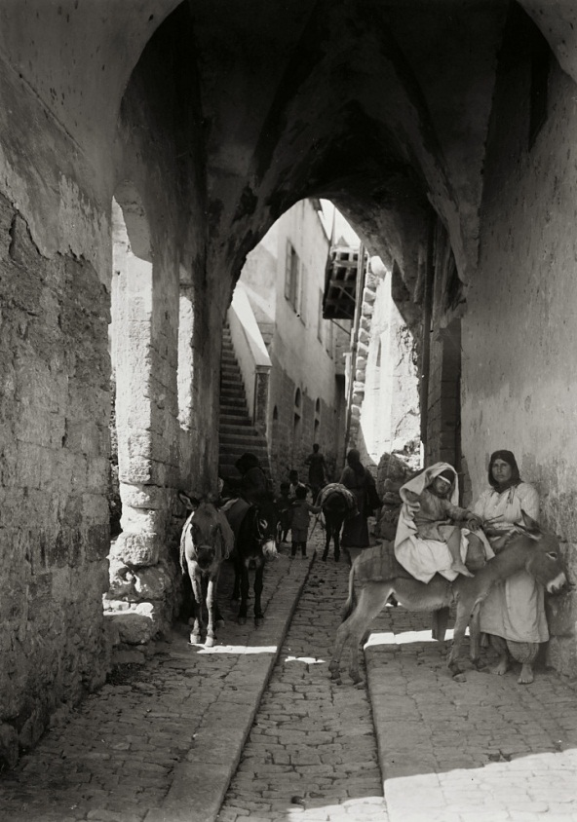
Nazareth

“Come and see,” said Philip.

⁴⁷ When Jesus saw Nathanael approaching, he said of him, “Truly, an Israelite in whom there is nothing false.”

⁴⁸ “How do you know me?” Nathanael asked.

Jesus answered, “I saw you while you were still under the fig tree before Philip called you.”

⁴⁹ Then Nathanael declared, “Rabbi, you are the Son of God; you are the King of Israel.”

⁵⁰ Jesus said, “You believe because I told you I saw you under the fig tree. You shall see greater things than that.” ⁵¹ He then added, “I tell you the truth, you shall see heaven open, and the angels of God ascending and descending on the Son of Man.”

John 2
Jesus Changes Water to Wine
¹ On the third day a wedding took place at Cana in Galilee. Jesus’ mother was there, ² and Jesus and his disciples had also been invited to the wedding. ³ When the wine was gone, Jesus’ mother said to him, “They have no more wine.”

⁴ “Dear woman, why do you involve me?” Jesus replied. “My hour has not yet come.”

⁵ His mother said to the servants, “Do whatever he tells you.”

⁶ Nearby stood six stone water jars, the kind used by the Jews for ceremonial washing, each holding from twenty to thirty gallons.

⁷ Jesus said to the servants, “Fill the jars with water”; so they filled them to the brim.

⁸ Then he told them, “Now draw some out and take it to the master of the banquet.”

They did so, ⁹ and the master of the banquet tasted the water that had been turned into wine. He did not realize where it had come from, though the servants who had drawn the water knew. Then he called the bridegroom aside ¹⁰ and said, “Everyone brings out the choice wine first and then the cheaper wine after the guests were inebriated; but you have saved the best till now.”

¹¹ This, the first of his miraculous signs, Jesus performed at Cana in Galilee. He thus revealed his glory, and his disciples put their faith in him.
Jesus Clears the Temple
¹² After this he went down to Capernaum with his mother and brothers and his disciples. There they stayed for a few days.

¹³ When it was almost time for the Jewish Passover, Jesus went up to Jerusalem. ¹⁴ In the temple courts he found men selling cattle, sheep and doves, and others sitting at tables exchanging money. ¹⁵ So he made a whip out of cords, and drove all from the temple area, both sheep and cattle; he scattered the coins of the money changers and overturned their tables. ¹⁶ To those who sold doves he said, “Get these out of here! How dare you turn my Father’s house into a market!”

¹⁷ His disciples remembered that it is written: “Zeal for your house will consume me.”

¹⁸ Then the Jews demanded of him, “What miraculous sign can you show us to prove your authority to do all this?”

¹⁹ Jesus answered them, “Destroy this temple, and I will raise it again in three days.”

²⁰ The Jews replied, “It has taken forty-six years to build this temple, and you are going to raise it in three days?” ²¹ But the temple he had spoken of was his body. ²² After he was raised from the dead, his disciples recalled what he had said. Then they believed the Scripture and the words that Jesus had spoken.

²³ Now while he was in Jerusalem at the Passover Feast, many people saw the miraculous signs he was doing and believed in his name. ²⁴ But Jesus would not entrust himself to them, for he knew all men. ²⁵ He did not need man’s testimony about man, for he knew what was in a man.

John 3
Jesus Teaches Nicodemus
¹ Now there was a man of the Pharisees named Nicodemus, a member of the Jewish ruling council. ² He came to Jesus at night and said, “Rabbi, we know you are a teacher who has come from God. For no one could perform the miraculous signs you are doing if God were not with him.”

³ In reply Jesus declared, “I tell you the truth, no one can see the kingdom of God unless he is born again.”

⁴ “How can a man be born when he is old?” Nicodemus asked. “Surely he cannot enter a second time into his mother's womb to be born!”

⁵ Jesus answered, “I tell you the truth, no one can enter the kingdom of God unless he is born of water and the spirit. ⁶ Flesh gives birth to flesh, but the spirit gives birth to spirit. ⁷ You should not be surprised at my saying, ‘You must be born again.’ ⁸ The wind blows wherever it pleases. You hear its sound, but you cannot tell where it comes from or where it is going. So it is with everyone born of the Spirit.”

⁹ “How can this be?” Nicodemus asked.

¹⁰ “You are Israel’s teacher,” said Jesus, “and do you not understand these things? ¹¹ I tell you the truth, we speak of what we know, and we testify to what we have seen, but still you people do not accept our testimony. ¹² I have spoken to you of earthly things and you do not believe; how then will you believe if I speak of heavenly things? ¹³ No one has ever gone into heaven except the one who came from heaven—the Son of Man. ¹⁴ Just as Moses lifted up the snake in the desert, so the Son of Man must be lifted up, ¹⁵ that everyone who believes in him may have eternal life.

¹⁶ “For God so loved the world that he gave his one and only Son, that whoever believes in him shall not perish but have eternal life. ¹⁷ For God did not send his Son into the world to condemn the world, but to save the world through him. ¹⁸ Whoever believes in him is not condemned, but whoever does not believe stands condemned already because he has not believed in the name of God’s one and only Son. ¹⁹ This is the verdict: Light has come into the world, but men loved darkness instead of light because their deeds were evil. ²⁰ Everyone who does evil hates the light, and will not come into the light for fear that his deeds will be exposed. ²¹ But whoever lives by the truth comes into the light, so that it may be seen plainly that what he has done has been done through God.”
John the Baptist's Testimony About Jesus
²² After this, Jesus and his disciples went out into the Judean countryside, where he spent some time with them, and baptized. ²³ Now John also was baptizing at Aenon near Salim, because there was plenty of water, and people were constantly coming to be baptized. ²⁴

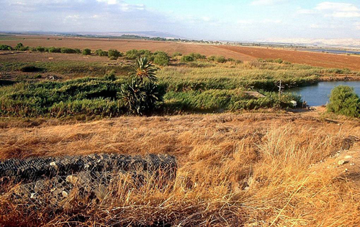
Salim

(This was before John was put in prison.) ²⁵ An argument developed between some of John's disciples and a certain Jew over the matter of ceremonial washing. ²⁶ They came to John and said to him, “Rabbi, that man who was with you on the other side of the Jordan—the one you testified about—well, he is baptizing, and everyone is going to him.”

²⁷ To this John replied, “A man can receive only what is given him from heaven. ²⁸ You yourselves can testify that I said, ‘I am not the Christ but am sent ahead of him.’ ²⁹ The bride belongs to the bridegroom. The friend who attends the bridegroom waits and listens for him, and is full of joy when he hears the bridegroom's voice. That joy is mine, and it is now complete. ³⁰ He must become greater; I must become less.

³¹ “The one who comes from above is above all; the one who is from the earth belongs to the earth, and speaks as one from the earth. The one who comes from heaven is above all. ³² He testifies to what he has seen and heard, but no one accepts his testimony. ³³ The man who has accepted it has certified that God is truthful. ³⁴ For the one whom God has sent speaks the words of God, for God gives the Spirit without limit. ³⁵ The Father loves the Son and has placed everything in his hands. ³⁶ Whoever believes in the Son has eternal life, but whoever rejects the Son will not see life, for God’s wrath remains on him.”

1 Corinthians

Introductory comments
Given the strategic location of Corinth, we can understand why Paul spent so much time there. The following reasons are given by Engels:
1. “As a major destination for traders, travelers, and tourists in the eastern Mediterranean, Corinth was an ideal location from which to spread word of a new religion.”
2. The city would also have provided Paul with “an opportunity to practice his own trade as tentmaker since there was probably a high demand for his products: tents for sheltering visitors to the spring games, awnings for the retailers in the forum, and perhaps sails for merchant ships.” It also gave him the opportunity for some measure of economic independence. We should remember that Paul did not separate working from preaching. He tells the Thessalonians, “We worked night and day in order not to be a burden to anyone while we preached the gospel of God to you” (1 Thess 2:9). His workshop became a public place from which he could preach the gospel to passersby (see Acts 17:17; 19:11–12).
3. Throughout the first century A.D. Corinth's economy was a magnet for immigrants from all over the eastern Mediterranean who came to work in its flourishing manufacturing, marketing, and service sectors. This influx of people provided increased opportunities to preach the gospel to those who would perhaps carry it further into the world as they traveled elsewhere. Engels cites a modern sociological assessment of those who live in cities: “A population concentrated in cities was more accessible to the influence of new ideological trends than a population scattered throughout the countryside. The man who had severed his traditional local ties to live in the impersonal and anonymous city searched for something he could identify with, for new loyalties and attachments.”17A city like Corinth provided many persons who might be open to hearing and believing the gospel of the crucified Lord.
According to Acts 18:1–8, Paul spent his first visit to Corinth trying to convince Jews attending the synagogue to believe that Jesus was the Messiah. He instructed the household of Gentiles who lived next to the synagogue, and Jewish anger over his preaching and perhaps his encroaching on the pool of Gentiles attracted to Judaism led to a riotous brush with the Roman governor, Gallio. The result of this first mission was that some Jews and Gentiles (see 1 Cor 12:2) responded to the gospel. Many things would have attracted both Jews and Gentiles to become Christian, namely, signs, wonders, and mighty works (2 Cor 12:12); Paul's persuasive interpretation of the Scripture (see 2 Cor 3:12–18); the community's care for one another; open acceptance of Gentile members, greater than they received in the synagogue; the theoretical absence of social boundaries (1 Cor 12:13; Gal 3:27–28); and the personal transformation worked by the Spirit (2 Cor 5:17). The result was a thriving and brilliant congregation composed of persons from mixed backgrounds and social standings. It was an explosive mix that led to dissension and rivalry that caused Paul much anguish and concern. NAC, 23-24.

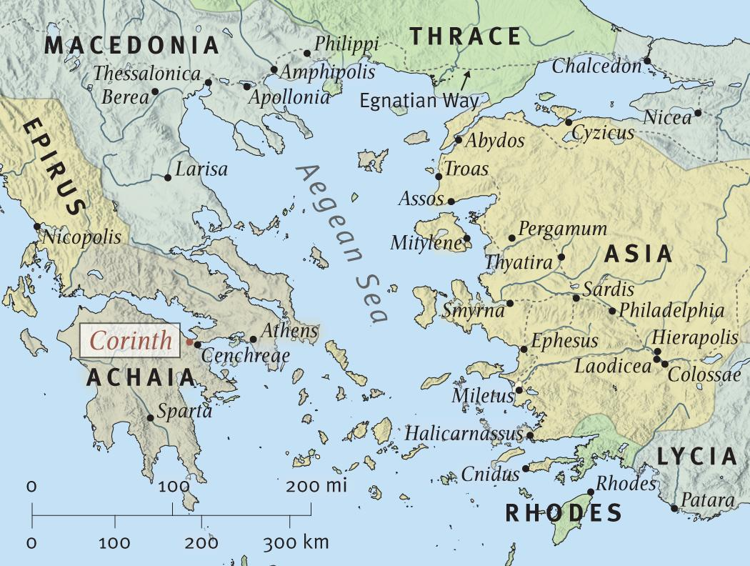

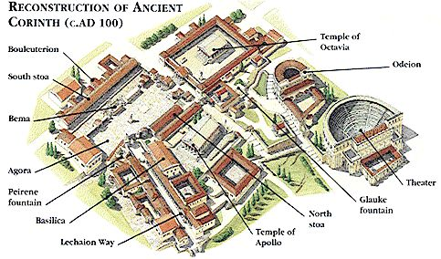

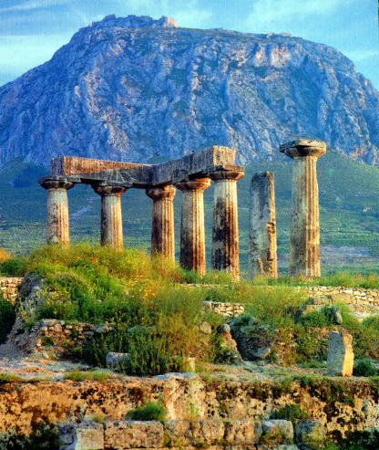
Temple of Apollo, ancient Corinth

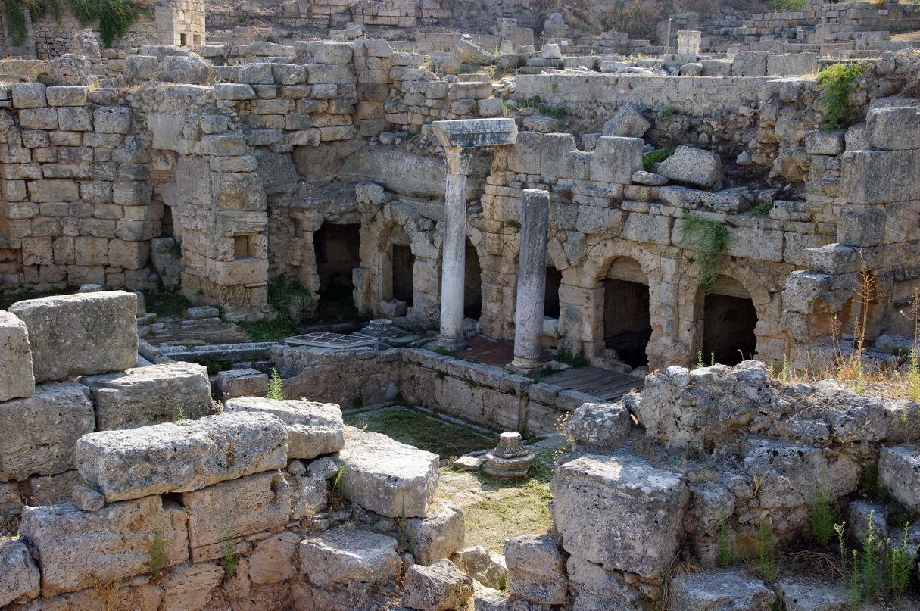
Peirene fountain

1 Corinthians 1

I. Introduction (1:1-9)

Salutation 1:1-3
Paul, called to be an apostle of Christ Jesus by the will of God, and our brother Sosthenes, ² To the church of God in Corinth, to those sanctified in Christ Jesus and called to be holy, together with all those everywhere who call on the name of our Lord Jesus Christ—their Lord and ours: ³ Grace and peace to you from God our Father and the Lord Jesus Christ.

Thanksgiving 1:4-9
4 I always thank God for you because of his grace given you in Christ Jesus. 5 For in him you have been enriched in every way—in all your speaking and in all your knowledge— 6 because our testimony about Christ was confirmed in you. 7 Therefore you do not lack any spiritual gift as you eagerly wait for our Lord Jesus Christ to be revealed. 8 He will keep you strong to the end, so that you will be blameless on the day of our Lord Jesus Christ. 9 God, who has called you into fellowship with his Son Jesus Christ our Lord, is faithful.

II. In Response to Reports (1:10-6:21)

A. A Church divided—Internally and against Paul (1-10-4:20)

1. The Problem—Division over Leaders in the Name of Wisdom (1:10-17)
10 I appeal to you, brothers, in the name of our Lord Jesus Christ, that all of you agree with one another so that there may be no divisions among you and that you may be perfectly united in mind and thought. 11 My brothers, some from Chloe’s household have informed me that there are quarrels among you. 12 What I mean is this: One of you says, “I follow Paul”; another, “I follow Apollos”; another, “I follow Cephas”; still another, “I follow Christ.” 13 Is Christ divided? Was Paul crucified for you? Were you baptized into the name of Paul? 14 I am thankful that I did not baptize any of you except Crispus and Gaius, 15 so no one can say that you were baptized into my name. 16 (Yes, I also baptized the household of Stephanas; beyond that, I don’t remember if I baptized anyone else.) 17 For Christ did not send me to baptize, but to preach the gospel—not with words of human wisdom, lest the cross of Christ be emptied of its power.

2. The Gospel—A Contradiction to Wisdom (1:18-2:5)

a. God’s folly—a crucified Messiah 1:18-25
18 For the message of the cross is foolishness to those who are perishing, but to us who are being saved it is the power of God. 19 For it is written: “I will destroy the wisdom of the wise; the intelligence of the intelligent I will frustrate.” 20 Where is the wise man? Where is the scribe? Where is the debater of this age? Has not God made foolish the wisdom of the world? 21 For since in the wisdom of God the world through its wisdom did not know him, God was pleased through the foolishness of what was preached to save those who believe. 22 Jews demand miraculous signs and Greeks look for wisdom, 23 but we preach Christ crucified: a stumbling block to Jews and foolishness to Gentiles, 24 but to those whom God has called, both Jews and Greeks, Christ the power of God and the wisdom of God. 25 For the foolishness of God is wiser than man’s wisdom, and the weakness of God is stronger than man’s strength.

b. God’s folly—the Corinthian Believers 1:26-31
26 Brothers, think of what you were when you were called. Not many of you were wise according to the flesh; not many were influential; not many were of noble birth. 27 But God chose the foolish things of the world to shame the wise; God chose the weak things of the world to shame the strong. 28 He chose the lowly things of this world and the despised things—and the things that are not—to nullify the things that are, 29 so that no flesh may boast before him. 30 It is because of him that you are in Christ Jesus, who has become for us wisdom from God—that is, our righteousness, holiness and redemption. 31 Therefore, as it is written: “Let him who boasts boast in the Lord.”

From: http://bibleatlas.org/azekah.htm.
Photos from: http://www.generationword.com/Israel/elah.html.
“This panoramic view of the Elah Valley from the south is an approximate view of what the Philistine army saw as they faced the Israelites in the battle commonly known as "David vs. Goliath." The Philistines were encamped on the south side of the valley and King Saul's forces occupied the hill on the northern side.” From: http://www.bibleplaces.com/elahvalley.htm.
600 shekels.
“Jesse had eight sons,” and “David was the youngest” (v. 14); these assertions are in tension with 1 Chr 2:13, though not contradicted by it. Though 1 Chr 2:13 notes only seven sons of Jesse and states that David was the seventh, the differences between the passages may simply be a matter of reckoning. If Jesse had a son who died, especially one who died as a minor, the Chronicler’s omission of that son could merely be the result of a difference in criteria for inclusion in the genealogical record. Robert D. Bergen, New American Commentary – Volume 7: 1, 2 Samuel, (Nashville, TN: Broadman & Holman, 1996), WORDsearch CROSS e-book, 189.
We cannot know how soon the events of this chapter occurred after the previous events. However, enough time must have passed for Saul to have changed his policy toward David, permitting him to return to Bethlehem. It also may have been long enough for the youthful David to mature and change significantly in appearance, though not long enough for David to have become old enough for military service (=age twenty; cf. Num 1:3; also 1 Sam 17:33). NAC, 187.
Saul’s reference to David’s adolescence suggests that David was under twenty years of age, the earliest age at which an Israelite was permitted to serve in the military (cf. Num 1:3; 26:2). NAC, 192.
This was a low position. David was doing the menial well.
Wow, this is an amazing amount of dedication! He might have just told his dad, “Hey, a lion ate another one!”
David went with what he knew rather than in a time of crisis depending on things he had never used. He had engaged in battles in the past and been successful because God had given him the victory. He now wasn’t going to depend of the advice of men which encouraged him to use human armor. I don’t want to go too far with this, however. It isn’t wrong to wear armor in a battle. And all of the time we need to hear the advice of others. David’s trust, however, wasn’t in the best weaponry. It was in the Lord.
Might have been too heavy to have more than five stones as each one was 2.5 to 3 inches in diameter.
“Not frightened in anything by your opponents….” Also, David was spiritually prepared for battle. It is also of interest to me that he had no intention of engaging Goliath in a sword fight. Goliath was well armed.
There was no point in walking!
The question arises as to how Saul could not know who David was. But that isn’t what Saul asks. Saul asks who David’s father is. This makes sense considering v. 25 where the family of the man who slays Goliath will be tax exempt.
Blomberg: “The most significant question in the history of interpretation has been whether to treat parables as detailed allegories or as simple, down-to-earth stories that make only one main point each. A growing number of scholars are recognizing that neither of these extremes can be justified and are opting for a variety of mediating perspectives. I believe that the parables are limited allegories and that we may usually associate one main point with each main character (or groups of characters), almost never more than three per parable. When elements of a parable were “stock metaphors” in ancient Judaism, we may usually assume that Jesus used them in similar fashion—e.g., masters, fathers, and kings for God; servants and sons for God’s people or helpers; a harvest for judgment and a feast for the messianic banquet, and so on. But all elements viewed as symbolic must be given interpretations that could have come readily to mind to a first-century Galilean, Jewish peasant audience. If there is doubt about whether a certain detail in a parable is significant, interpreters should err on the side of caution and not read in meaning that may not be present. “The main question for interpreting parables in Matthew involves the role of this chapter in its overall narrative flow. Classic dispensationalism sees Matt 13 as the turning point of Jesus’ ministry when he withdrew his offer of the kingdom from Israel. This view requires seeing the rejection of “this generation” in chaps. 11–12 as fairly official or absolute. But positive and negative responses from the Jews in fact continue all the way to the crucifixion. So it is better to think of a series of shifts in reaction to Jesus throughout the Gospel. Parables are not a new form of teaching characteristic of a new phase of ministry at this point in Matthew (cf. 7:24–27; 9:16–17; 11:16–19; 12:29), and Jesus will often continue to address his critics with more straightforward language (15:3–7; 16:2–4; 19:4–9, 17–22; and much of chaps. 21–23). Instead, the parables appear here as an important explanation of why the response to Jesus is becoming increasingly polarized and as a prediction of how that polarization will continue to grow. For those whose hearts are already hardened, parables conceal, even as they reveal new truths for those who are more receptive (vv. 12–13). Matthew 21:45 makes clear that the understanding of the parables is not so much cognitive as volitional. Those outside the kingdom “understand the provocative claim of the parables very well, but they are not prepared to accept it … Jesus’ speaking in parables is not a riddle as such. What is perplexing is the behavior that it calls forth—that man can see salvation personified and nevertheless not come to conversion and belief.” Again, “Jesus deliberately concealed the Word in parable lest men against their will should be forced to acknowledge the Kingdom, and yet He allowed them enough light to convict them and to convince them.” Craig L. Blomberg, New American Commentary – Volume 22: Matthew, (Nashville, TN: Broadman & Holman, 1992), WORDsearch CROSS e-book, 210-212.
Carson: some scholars “convincingly demonstrate that the allegory-parable distinction is too facile, that Jesus himself occasionally derived more than one or two points from certain of his parables, and that all ‘allegorizing’ of the parables cannot be automatically assigned to the postapostolic church…. Thus a parable can be a proverb (Luke 4:23…); a profound or obscure saying (Matt 13:35); a nonverbal symbol or image (Heb 9:9; 11:19); an illustrative comparison, whether without the form of a story (Matt 15:15; 24:32)… ; an illustrative story not involving comparison of unlikes (e.g., the rich fool, Luke12:16-21; and more.” See p. 303.
Consider that the sower doesn’t try to sow seed on rocky soil or in soil with thorns but the seed ends up there anyway. Likewise, our Father might not be working that diligently to make sure that everyone in the rocky or thorny soil places of this world has an opportunity to hear the Gospel. He knows what type of soil they are.
S. Kistemaker concisely captures the three main points of the passage and the three subpoints under the final point: “The Word of God is proclaimed and causes a division among those who hear; God’s people receive the Word, understand it, and obediently fulfill it; others fail to listen because of a hardened heart, a basic superficiality, or a vested interest in riches and possessions.” The parable provides a sober reminder that even the most enthusiastic outward response to the gospel offers no guarantee that one is a true disciple. Only the tests of time, perseverance under difficult circumstances, the avoidance of the idolatries of wealth and anxiety over earthly concerns (recall 6:25–34), and above all the presence of appropriate fruit (consistent obedience to God’s will) can prove a profession genuine. Craig L. Blomberg, NAC, 217.
Carson: His heart is the place of decision.
Carson: “Receives the word in a thoughtless way.”
When this world is threatened, they fall away.
Carson: “This person does not hear the word ‘with joy’ (as in v.20) but simply never permits the message about the kingdom to control him: life has too many other commitments that slowly choke the struggling plant, which never matures and bears fruit.” 314. Failure to thrive. Perhaps areas of affluence where it is easy to love this world?
This is a longer process and doesn’t it apply to many Christians today?
Closely related to the parable of the sower. In the Sower we see four types of people but only one who continues in Jesus. In the parable of the wheat and the tares, we learn about those who continue to bear the name but who really weren’t saved in the first place.
They were familiar with the “seed” that was promised to Adam and Eve. “Mustard seeds were the smallest seeds commonly planted in Palestinian fields. “Garden plants” is thus better translated herbs or vegetables. Mustard plants usually look more like large bushes than like small trees, but they can grow to ten or twelve feet, enabling birds to roost in their branches (“perch” equals nest or live). Jesus may be alluding to Ezek 17:23 (cf. Dan 4:12), in which the birds of the air nest in the branches of the mighty cedar tree (God's kingdom in Israel). Even large mustard bushes pale in comparison with the lofty cedar; still Jesus may be employing deliberate irony. What may not look like much to the world will in fact fulfill all God’s promises.” Craig L. Blomberg, NAC, 219.
Geisler, WCA: “Jesus was not referring to all the seeds in the world, but only those that a Palestinian farmer sowed in his field. This is made clear by the qualifying phrase “which a man took and sowed in his field” (v. 31). And it is a fact that the mustard seed was the smallest of all seeds which the 1st century farmer sowed in his field.”
Or, a “husband.”
Lit. the Word “pitched His tabernacle” or “lived in his tent among us.” Greek speaking Jews would immediately think of the tabernacle of Ex. 25:8-9.
Carson: “The next of textual variants is rather complicated, but probably the right reading is monogenēs theos, ‘the unique and beloved one, [himself] God’….”
Lit. “who is in the bosom of the Father.”
John did not detect as much significance in his own ministry as Jesus did. Carson.
Isaiah 40:3: Comfort, comfort my people, says your God. Speak tenderly to Jerusalem, and cry to her that her warfare is ended, that her iniquity is pardoned, that she has received from the LORD’s hand double for all her sins. A voice cries: “In the wilderness prepare the way of the LORD; make straight in the desert a highway for our God. Every valley shall be lifted up, and every mountain and hill be made low; the uneven ground shall become level, and the rough places a plain. And the glory of the LORD shall be revealed, and all flesh shall see it together, for the mouth of the LORD has spoken.”
From Wikipedia.
Carson: the word literally means “my great one.”
“Cephas” is Aramaic.
Matson photo collection.
The question then was whether Jesus in a public setting should submit to the private authority of his mother, who by right of motherhood could use her son’s resources to recoup her honor and those of her associates in the context of a failed situation that was soon to be evident in public at the feast.” NAC Carson points out that this was a shame culture and a wedding celebration might go on for a week. The groom could even be open to lawsuit from the aggrieved relatives of the bride. That the “wine” was mere “grape juice” is “intrinsically silly as applied to countries whose agricultural tradition is so committed to viticulture. Besides, in v. 10 the head steward expects that at this point in the celebration some of the guests would have had too much to drink; the verb methysko does not refer to consuming too much liquid, but to inebriation. On the other hand, wine in the ancient world was diluted with water to between one-third and one-tenth of its fermented strength, i.e. something less strong than American beer. Undiluted wine, about the strength of wine today, was viewed as ‘strong drink’, and earned much more disapprobation.” 169 Caron suggests that Mary had been used to relying on Jesus as Joseph was probably dead by this time (there is no mention of him after Jesus was 12. Mary must have found Jesus to be extremely resourceful in life and was probably not expecting a miracle since Jesus hadn’t done any yet.
I read Carson’s comments and think that although “dear woman” is too sentimental it is still probably the best there is.
This is an attempt to soften the language. Lit. “woman, what to me and to you.” “Thus family relationships were not to be the determining factors in Jesus’ life.”… Although a Jewish mother might normally be able to exercise pressure on her children, it was not to be the case with Jesus. Carson: “The expression is, at the very least, a measured rebuke…. We must not avoid the conclusion that Jesus by rebuking his mother, however courteously, declares, at the beginning of his ministry, his utter freedom from any kind of human advice, agenda or manipulation.” 171
The hour where he pours out himself for humankind hasn’t come.
The person in charge is no longer Jesus mother. Carson points out that Mary responds in faith by leaving the matter in Jesus hands.
20 to 30 is a good rendering.
Although the level of intoxication is unknown, Carson says this means that they were inebriated. Interesting point to me is that Jesus provided wine after the guests had already had a lot to drink. Carson says “the idea [that it was “mere grape juice”] is intrinsically silly as applied to the countries whose agricultural tradition is so committed to viticulture. Besides, in v. 10 the head steward expects that at this point in the celebration some of the guests would have had too much to drink: the verb methyskō does not refer to consuming too much liquid, but to inebriation. On the other hand, wine in the ancient world was diluted with water to between one-third and one-tenth of its fermented strength, i.e. something less strong then American beer. Undiluted wine, about the strength of wine today, was viewed as ‘strong drink’, and earned much more disapprobation” 169, emphasis his.
They were no longer John’s disciples but His.
The sign of Jonah! Again Jesus says that He does give evidence for the truth of who He is.
Sanhedrin—one of the 70. The Sanhedrin Council acted in all matters religious as the Supreme Court. Its scope also extended to many civil and criminal matters as authorized by the law. The Romans, however, maintained ultimate control in criminal matters, particularly in the area of maestas or treason in which the death penalty was customary. The Council was composed of both Pharisees and Sadducees with the high priests being primarily from the Sadducean group. In the time of the writing of the Gospel the Sadducees had all but faded from the scene following the fall of Jerusalem.” NAC
“But most commentators are agreed that the reference to night is a picture of a man who was in an uneasy state of unbelief or doubt.”—NAC
Being born into Adam’s family is surely not enough. “Born again” sounds like a “do-over.”
Carson says Nicodemus as a teacher of Israel should have understood passages like Ezekiel 36:25-27 (ESV) “I will sprinkle clean water on you, and you shall be clean from all your uncleannesses, and from all your idols I will cleanse you. 26 And I will give you a new heart, and a new spirit I will put within you. And I will remove the heart of stone from your flesh and give you a heart of flesh. 27 And I will put my Spirit within you, and cause you to walk in my statutes and be careful to obey my rules.” Carson argues that the capital “Spirit” as found in NIV should be dropped as the focus is on “the impartation of God’s nature as ‘spirit’ [cf. 4:24], not on the Holy Spirit as such….” (195) Me: it seems this would relate at least somewhat to John’s baptism of repentance. Carson: “Apparently Nicodemus had not thought of the Old Testament passages in this way. If he was like some other Pharisees, he was too confident in the quality of his own obedience to think that he needed much repentance.”
Carson thinks “human nature” is what is meant by “flesh.”
Nicodemus comes to Jesus and says “we know you are a teacher.” To this Jesus basically responds that we know things too. In my opinion, Jesus is speaking here of the Father.
Earthly in the sense that being born again is something that happens here on earth. If Nicodemus had asked about what the coming kingdom would be like then it would have been strictly from above.
Carson thinks 16-21 are the Evangelist’s reflections.
From: http://www.welcometohosanna.com/LIFE_OF_JESUS/020_Ministry1jacobwell.htm.
See 3:35 Where Morris writes: “We read again of the Father as having given ‘all things into his hands’ (13: 3; cf. Matt. 11:27; Luke 10:22). Specifically the Father gave Christ the Spirit (v. 34), the work He accomplished (17), and the works He did (5:36; cf. 14:31), His message (12:49; 17:8), His authority (17:2), His name (17:11), His glory (17:22-24), His disciples (6:37-39; 10:29; 17:6, 9, 12, 24; 18:9), the cup He must drink (18:11), ‘all judgment’ (5:22), ‘to have life in himself’ (5:26), and power over all flesh (17:2.).” 247.
Carson thinks these words are the words of the Evangelist.
Corinth, because of its location, controlled both the overland commercial traffic and that between Italy and Asia. Fee: “The city’s history is essentially in two parts. As a Greek city-state it flourished both before and after the golden years of Athens (5th C. B. C.). But as leader of the Achaean League in the mid-second century B. C., it came into conflict with Rome and was destroyed by the Roman consul Lucius Mumius in 146 B. C. The site lay dormant for one hundred years, until it was refounded in 44 B. C. by Julius Caesar as a Roman colony.” Fee “Old Corinth had gained such a reputation for sexual vice that Aristophanes (ca. 450-385 B.C.) coined the verb korinthiazo (=to act like a Corinthian, i.e., to commit fornication). The Asclepius room in the present museum in Corinth provides mute evidence of this facet of city life; here on one wall are a large number of clay votives of human genitals that had been offered to the god for the healing of that part of the body, apparently ravaged by venereal disease.” Corinthians is an occasional letter written in response to the Corinthian situation which developed sometime after Paul left the city 51-52 A.D. Fee (page 5): Our difficulty at this distance is threefold: - To discover the relationship, if indeed there is one, of these various items to one another; - To determine the relationship of the community to Paul - To determine what influences/positions in the Corinthian ‘theology’ allowed them not only to adopt such behavior but also to argue for the right to do it. In every case Paul’s greatest concern is the theological stance behind the behavior. Paul is taking them on at every turn (Fee, 6) The occasion of 1 Corinthians: “Our letter records Paul’s third dealings with this church. This is probably Paul’s third exchange of letters between Paul and Corinth. - Paul’s first association with them was the founding visit mentioned in Acts 18 (ca. A.D. 49-51), a visit that had a unique feature to it—the length of stay. - A couple of years later while Paul was in Ephesus, he wrote the previous letter mentioned in 1 Cor. 5:9. It at least dealt with sexual immorality and not associating with brothers who acted in such a way. In 5:10 he also mentions covetous, robbers, and idolaters. It seems clear from 1 Cor. 5 that the Corinthians misunderstood the first letter or perhaps, even more likely, that they have disregarded it (see 5:9-11). - That leads us to Paul’s third dealing with the Corinthians which is 1 Corinthians. 1 Cor. is a response to a letter from the Corinthians where they seem to have taken exception to some of Paul’s positions and/or prohibitions. The situation is further exacerbated by some communication from some believers from Chloe’s household 1:11. This communication probably helps Paul understand their letter. Paul’s difficulties are two fold. He must reassert his authority in a situation where it has severely eroded and this is made more difficult by his use of servant imagery as the model of leadership for the church (3:5-9; 4:1-5). How shall he reassert his own authority over them and not destroy the perspective of that imagery? Also, he must convince them to change both their theology and their behavior to conform to his since they are moving towards positions that threaten the Gospel itself. 2 Cor. tells us that some serious tension had developed between Paul and the Corinthians. The problems seem to have been initiated by few 1:12, 4:3, 6, 18-20; 9:3; 10:29-30, etc. See Fee fn. 8. but has infect the majority. Paul writes “do you not know that” ten times and with sarcasm “and if anyone thinks that he or she…” three times.
http://www.faithcrc.net/?p=1678.
http://www.abu.nb.ca/courses/ntintro/paulcareer5.htm.
http://upload.wikimedia.org/wikipedia/commons/b/b4/Temple_of_Apollo_Ancient_Corinth.jpg
http://upload.wikimedia.org/wikipedia/commons/1/1f/GR-korinth-peirene.jpg
Basic outline of book that of Gordon Fee. Fee says Corinth was a “relatively young city—only ninety-four years old when Paul first visited it. Yet because of its strategic location for commerce, it was cosmopolitan, wealthy, a patron of the arts, religious (at least twenty-six temples and shrines), and well-known for its sensuality.” How to Read the Bible, 59. “The Corinthian believers are chiefly Gentiles, although there are some Jews (see 6:9-11, etc.)” Fee, How To, 60.
Acts 18:17 (ESV): And they all seized Sosthenes, the ruler of the synagogue, and beat him in front of the tribunal. But Gallio paid no attention to any of this.
ESV: “Saints.” Perhaps “holy ones”?
A spiritual elitism not unlike the others. The whole church has fallen for a love of disputation. Fee, 59.
Jewish synagogue leader mentioned in Acts 18:8.
Rom. 16:23: “Gaius, whose hospitality I and the whole church here enjoy, sends you his greetings.” Paul was probably in Corinth when he wrote the letter to Rome. Fee, 62.
Fee says that Stephanas might have interrupted and reminded Paul. 1 Cor. 16:15 You know that the household of Stephanas were the first converts in Achaia, and they have devoted themselves to the service of the saints. I urge you, brothers, 16 to submit to such as these and to everyone who joins in the work, and labors at it. 17 I was glad when Stephanas, Fortunatus and Achaicus arrived, because they have supplied what was lacking from you. 18 For they refreshed my spirit and yours also. Such men deserve recognition.
Not with rhetorical skill. There is a temptation to make the Gospel more palatable. More hospitable. Make it sound wiser.
Perhaps the message of Christianity was too foolish and some were making it more erudite?
Fee: This certainly “would refer to the Greek thinker or philosopher….” 71.
Gk: γραμματεύς. Obviously Paul is keeping up the Jewish and Gk. philosopher comparison. Clearly Jewish in origin as the Greeks didn’t call their scholars “scribes.”
In both cases it is anthropos.
Sarx: “Human” in NIV or “worldly” in the ESV.
How can God prove that beauty, strength, and money aren’t necessary unless He uses the plain, weak, and poor to accomplish His purposes?

